Screenshot for Lab 6

==================

Login Page:

Logged in as Admin

After Signing in as admin

Inserting student details -

After adding Student details.

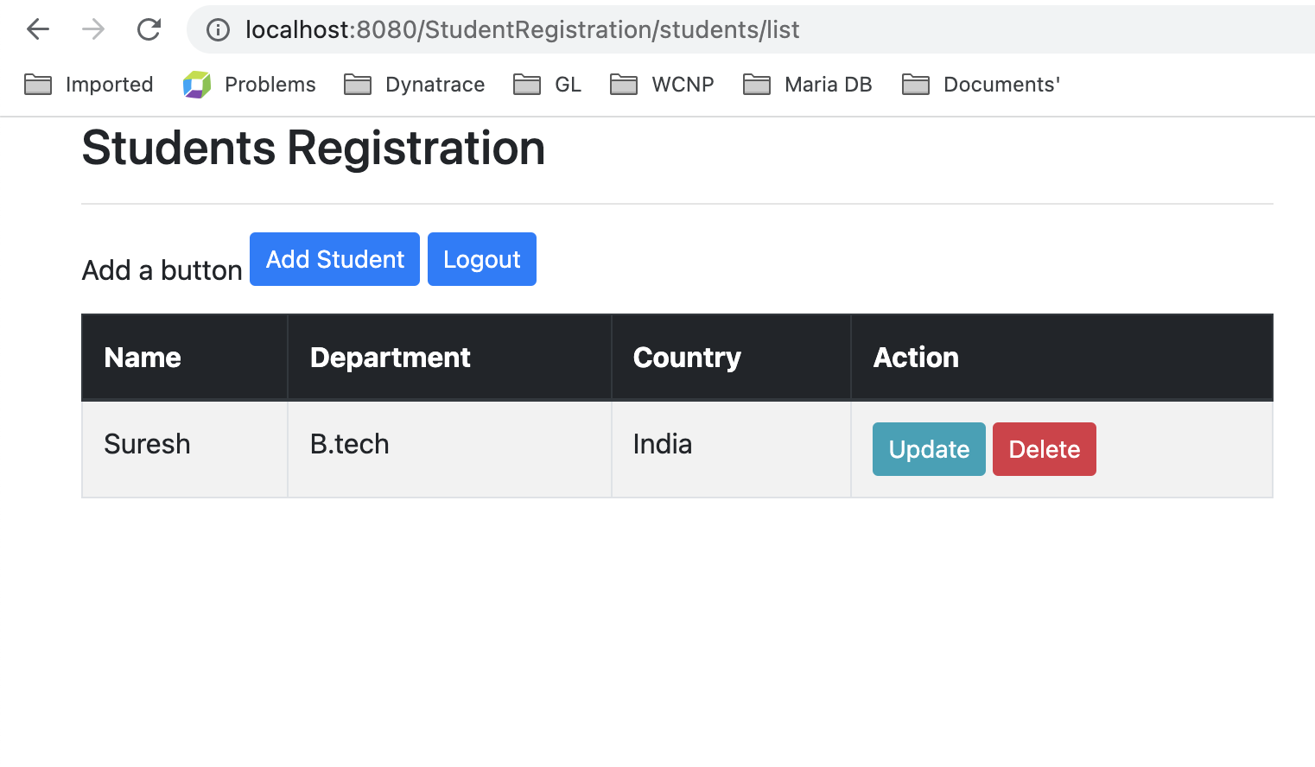

Updating Student details

Save the updated details

Adding few more students

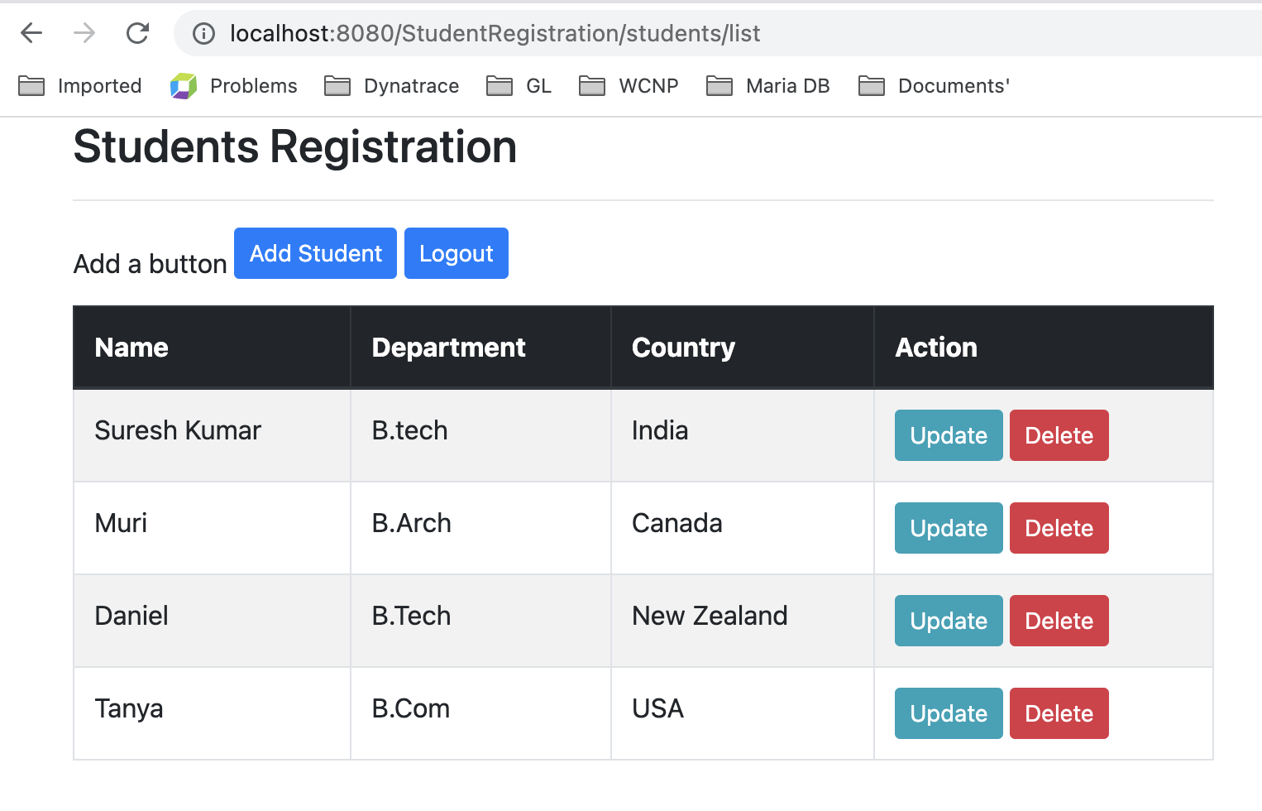

Deleting the Student Daniel

After deleting the user Daniel

Admin User Access can perform all operations as shown above where he can view,insert,update and delete.

Logging in as general user

Adding another student

Saving the student Sharmila as general user.

Updating Dept using General role access

Delete the student using general role access

General User has access can only view and add a Student. He cannot delete or update the student details.

---------------------------------------------------------THE END---------------------------------------------